Docker Task -3

**Task Description:** Create a custom docker image for nginx and deploy it using docker compose, where the volume bind mount should be at /var/opt/nginx location. Push the created custom docker image to your docker-hub

Step 1: Aws ubuntu server created with existing security group which is created for previous docker task.

Step 2: Install docker

sudo apt update -y

sudo apt install -y docker.io

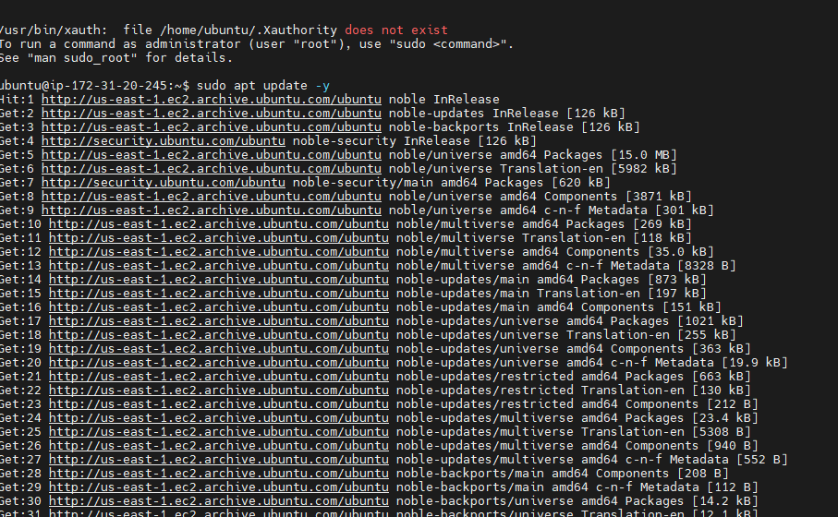



step3 : Add user to the docker group

sudo usermod -aG docker $USER

newgrp docker

step 4: check version docker –version

step 5: login docker 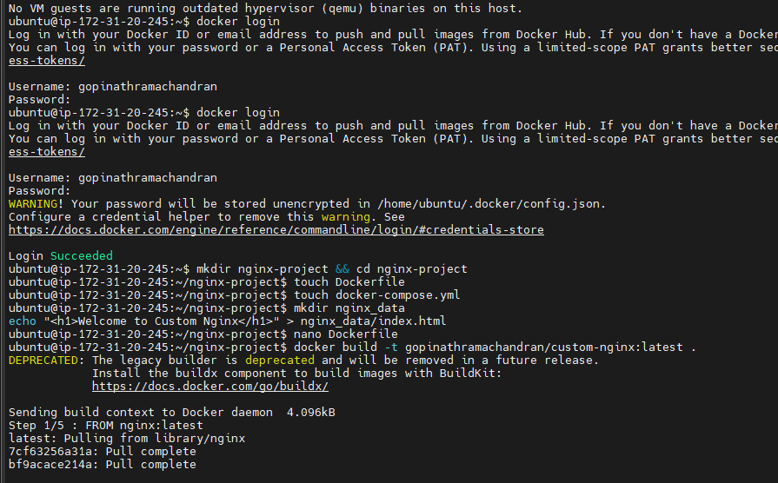

Step 6: Make directory for Ngnix-project and change directory to the same

Step 7: create required files

Create a custom Nginx Dockerfile

Build and tag the image

Push it to Docker Hub

Deploy using Docker Compose

Config nano ngnix.conf file then build

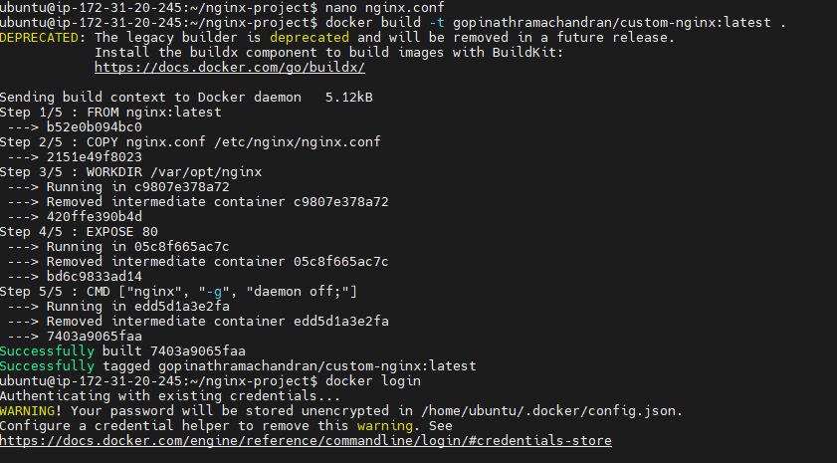



Step 8: create- nano Docker file

# Use the official Nginx base image

FROM nginx:latest

# Copy custom configuration if needed

COPY nginx.conf /etc/nginx/nginx.conf

# Set working directory

WORKDIR /var/opt/nginx

# Expose port 80

EXPOSE 80

# Start Nginx

CMD ["nginx", "-g", "daemon off;"]

Step 9: Build and Tag the Image

docker build -t gopinathramachandran /custom-nginx:latest .

step 10:

edit docker-compose.yml

version: '3.8'

services:

nginx:

image: <your-dockerhub-username>/custom-nginx:latest

container_name: custom-nginx

ports:

- "8080:80"

volumes:

- ./nginx_data:/var/opt/nginx

restart: always

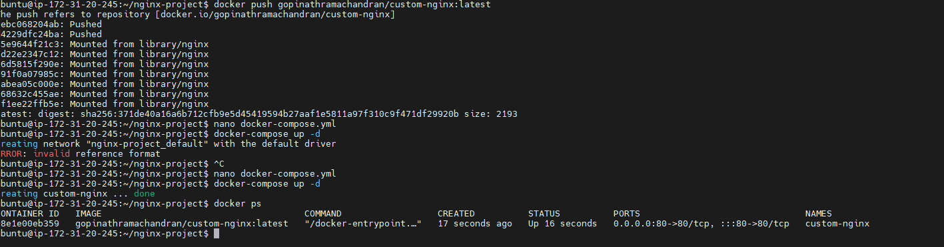

step 11

Deploy Using Docker Compose and verify

docker-compose up -d

docker ps

step 12

Access Nginx in a browser:  
Open http://34.229.83.17:8080 in your web browser. 